**Nashville Housing Analysis Answers**

**1: What are the number of houses for sale by Acreage Range?**

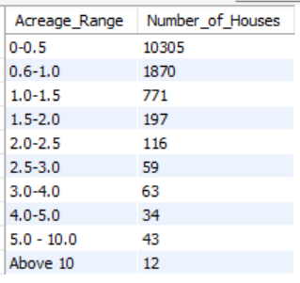

**2: What are the number of houses for sale by City?**

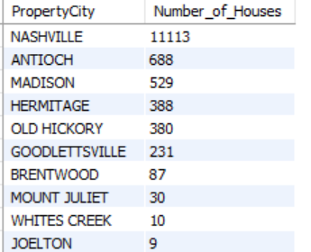

**3: What are the average prices per city?**

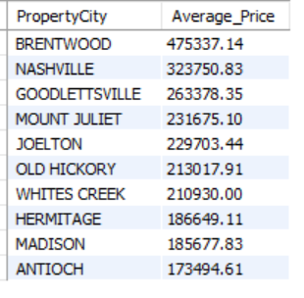

**4: What are the total acreage by city?**

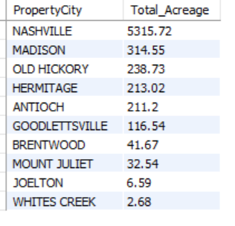

**5: What is the land value by city?**

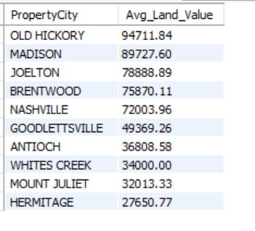

**6: What is the Building value by city?**

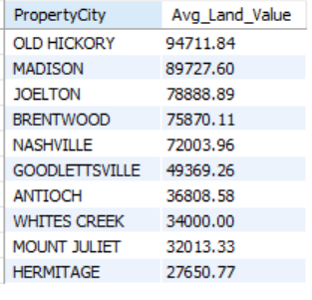

**7: What is the sale price by land use?**

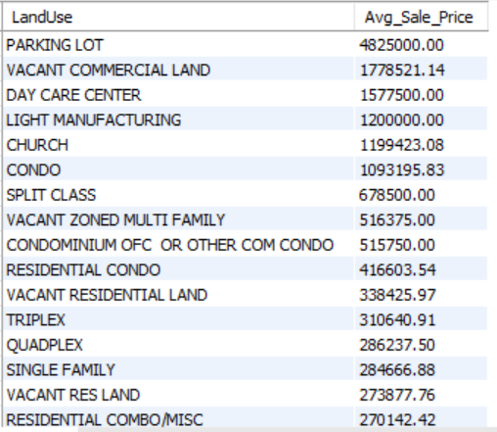

**8: What is the sale price by number of bedrooms?**

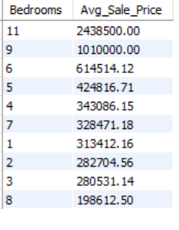

**9: What is the sale price by number of FullBaths?**

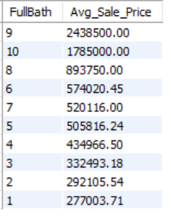

**10: What is the sale price by number of HalfBaths?**

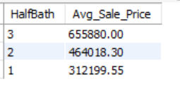

**11: What is the sale price by based on whether the house was vacant or not?**

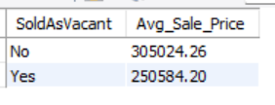

**12: What is the sales margin/value based on the different cities?**

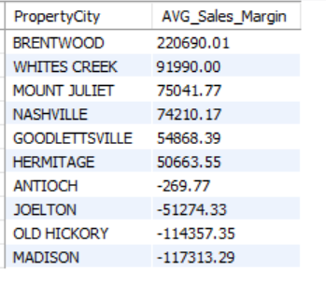

**13: Which months record the most sales?**

